Kubernetes Task-03

- Create a ClusterIP service for an Apache web server pod.
- Expose an Nginx pod externally using a NodePort service.
- Deploy a ReplicationController to maintain 3 replicas of an Nginx pod.
- Scale the ReplicationController from 3 replicas to 5 replicas.
- Create a ReplicaSet to manage pods based on multiple labels (prod and test).
- Deploy a ReplicaSet that excludes pods with the label backend.
- Test load balancing across multiple pods using a NodePort service.
- Delete a ReplicationController without affecting the running pods.

Task 1 — Create a ClusterIP Service for an Apache Web Server Pod

1. Objective
Create an Apache web server Pod and expose it using a ClusterIP Service.
The service will be accessible only from inside the Kubernetes cluster.

What we will learn
- Pod creation
- Labels
- ClusterIP Service
- Service selector
- Internal Kubernetes networking
- Accessing a Service from another Pod

2. Architecture
Kubernetes Cluster
|
|
ClusterIP Service
apache-service
10.x.x.x:80
|
|
Apache Pod
apache-pod
|
HTTP
|
Apache Web Server

Flow
- We create an Apache Pod.
- The Pod receives a label such as app=apache.
- We create a ClusterIP Service called apache-service.
- The Service searches for Pods having the label app=apache.
- Kubernetes connects the Service to the Apache Pod.
- Other Pods inside the cluster can access Apache through the Service.
- Users outside the cluster cannot directly access a ClusterIP Service.

3. Implementation

Step 1 — Create the Apache Pod
Create a YAML file:
nano apache-pod.yaml
Add:
apiVersion: v1
kind: Pod
metadata:
name: apache-pod
labels:
app: apache
spec:
containers:
- name: apache
image: httpd
ports:
- containerPort: 80
Save the file.
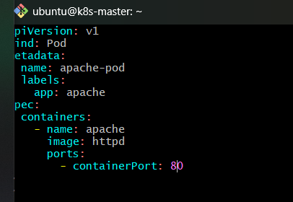

Understand the YAML
metadata:
name: apache-pod
This creates a Pod named:
apache-pod

labels:
app: apache
This is very important.
The Service will use this label to find the Pod.
Think of it as:
Pod
|
└── label: app=apache

image: httpd
The container uses the official Apache HTTP Server image.

containerPort: 80
Apache listens on HTTP port 80.

Step 2 — Create the Apache Pod
Run:
kubectl apply -f apache-pod.yaml
Expected:
pod/apache-pod created

Step 3 — Verify the Pod
Run:
kubectl get pods
Expected:
NAME READY STATUS RESTARTS AGE
apache-pod 1/1 Running 0 ...
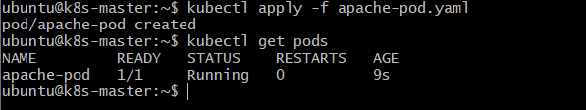
If you see:
1/1 Running
the Apache Pod is running successfully.

Step 4 — Verify the Pod Label
Run:
kubectl get pod --show-labels
You should see something similar to:
NAME READY STATUS RESTARTS AGE LABELS
apache-pod 1/1 Running 0 ... app=apache
The important part is:
app=apache
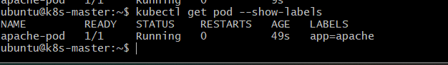

Step 5 — Create the ClusterIP Service
Create:
nano apache-service.yaml
Add:
apiVersion: v1
kind: Service
metadata:
name: apache-service
spec:
type: ClusterIP
selector:
app: apache
ports:
- port: 80
targetPort: 80
Save the file.
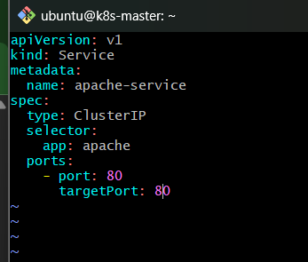

Step 6 — Understand the Service YAML
The important part is:
type: ClusterIP
This tells Kubernetes:
Create an internal service that is accessible inside the cluster.

This:
selector:
app: apache
means:
Find Pods having the label app=apache.
Our Apache Pod has:
labels:
app: apache
Therefore:
Service
|
| selector: app=apache
|
↓
apache-pod

This:
ports:
- port: 80
targetPort: 80
means:
Service port 80
|
↓
Pod port 80

Step 7 — Create the Service
Run:
kubectl apply -f apache-service.yaml
Expected:
service/apache-service created
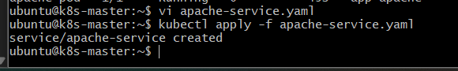

Step 8 — Verify the Service
Run:
kubectl get svc
Expected output will look similar to:
NAME TYPE CLUSTER-IP EXTERNAL-IP PORT(S)
apache-service ClusterIP 10.99.x.x <none> 80/TCP
Notice:
TYPE = ClusterIP
and:
EXTERNAL-IP = <none>
That's because this Service is internal only.
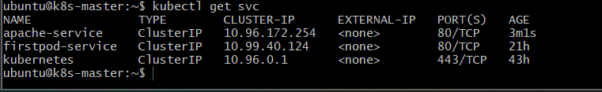

Step 9 — Check the Service Details
Run:
kubectl describe svc apache-service
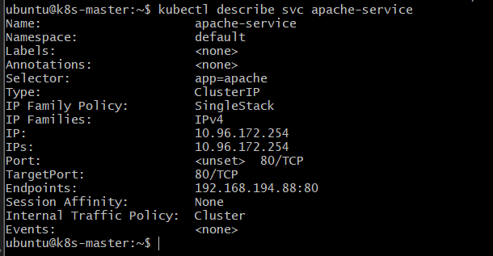
Look for:
Selector: app=apache
Port: 80/TCP
TargetPort: 80/TCP
Endpoints: <Pod-IP>:80
The Endpoints section is particularly important.
For example:
Endpoints: 192.168.194.80:80
This means Kubernetes has successfully connected the Service to the Apache Pod.
The architecture is now:
apache-service
ClusterIP
|
| selector: app=apache
|
↓
apache-pod
Pod IP: 192.168.x.x
Port: 80

Step 10 — Test the Service from Inside the Cluster
Because ClusterIP is internal, we'll create a temporary test Pod.
Run:
kubectl run test-pod --image=curlimages/curl -it --rm -- sh
You should get a shell inside the temporary Pod.
Now run:
curl http://apache-service
You should receive Apache's HTML response, something similar to:
<html><body><h1>It works!</h1></body></html>
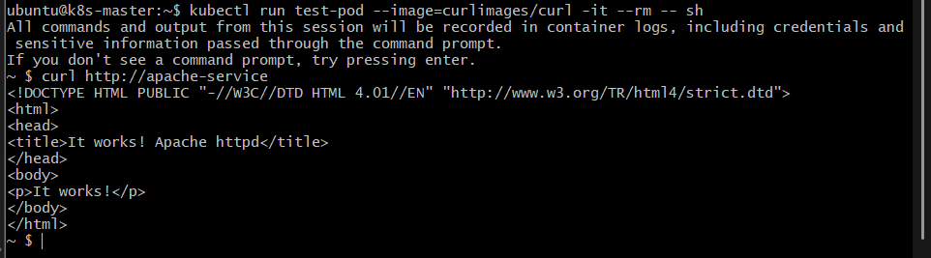
This proves:
test-pod
|
| HTTP request
↓
apache-service
|
↓
apache-pod
|
↓
Apache

Step 11 — Exit the Test Pod
Run:
exit
Because we used:
--rm
the temporary Pod will automatically be removed.
Verify:
kubectl get pods
You should only see:
apache-pod
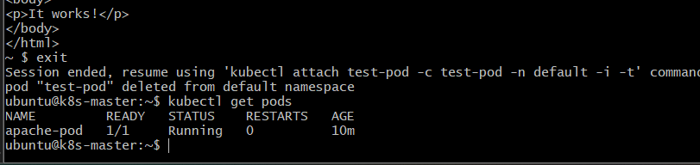

4. Validation Checklist
Run:
kubectl get pods
Expected:
apache-pod 1/1 Running
Then:
kubectl get svc apache-service
Expected:
apache-service ClusterIP 10.x.x.x <none> 80/TCP
Then:
kubectl describe svc apache-service
Confirm:
Selector: app=apache
and:
Endpoints: <Apache-Pod-IP>:80
Finally:
kubectl run test-pod --image=curlimages/curl -it --rm -- sh
Inside it:
curl http://apache-service
Apache's response confirms that the Service is working.

5. Expected Final Architecture
Kubernetes Cluster
|
|
┌─────────────────────┐
│ apache-service │
│ ClusterIP │
│ Port 80 │
└──────────┬──────────┘
|
selector:
app=apache
|
↓
┌───────────────┐
│ apache-pod │
│ │
│ Apache/httpd │
│ Port 80 │
└───────────────┘

Important concept
ClusterIP does not expose the application directly to the outside world.
Outside Kubernetes
X
|
X Not directly accessible
|
ClusterIP Service
|
↓
Apache Pod
But from another Pod:
Pod inside cluster
|
↓
apache-service
|
↓
Apache Pod
works.

6. Outcome
After completing Task 1, you will have:
- Created an Apache web server Pod.
- Assigned the Pod the label app=apache.
- Created a ClusterIP Service named apache-service.
- Connected the Service to the Apache Pod using a selector.
- Verified the Service endpoint.
- Successfully accessed Apache from inside the Kubernetes cluster.

Task 2 — Expose an Nginx Pod Externally Using NodePort

1. Objective
Create an Nginx Pod and expose it outside the Kubernetes cluster using a NodePort Service.
Unlike ClusterIP, a NodePort allows clients outside the cluster to access the application through the IP address of a Kubernetes node + NodePort.

2. Architecture

External Client
|
| HTTP
| NodeIP:30080
↓
┌─────────────────┐
│ NodePort Service│
│ nginx-service │
│ Port: 80 │
│ NodePort: 30080 │
└────────┬────────┘
|
↓
┌────────────┐
│ Nginx Pod │
│ :80 │
└────────────┘

Flow
- We create an Nginx Pod.
- The Pod gets the label app=nginx.
- We create a NodePort Service.
- The Service selects the Nginx Pod using app=nginx.
- Kubernetes assigns/exposes a NodePort, such as 30080.
- A client can access http://<NodeIP>:30080.
- The NodePort forwards the request to the Nginx Pod on port 80.

3. Implementation

Step 1 — Create the Nginx Pod
Create the YAML file:
nano nginx-pod.yaml
Add:
apiVersion: v1
kind: Pod
metadata:
name: nginx-pod
labels:
app: nginx
spec:
containers:
- name: nginx
image: nginx
ports:
- containerPort: 80
Save and exit.
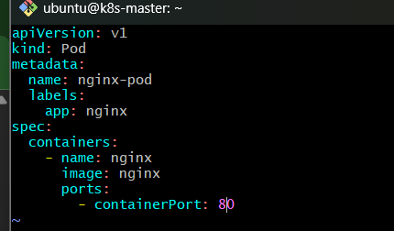

Step 2 — Create the Nginx Pod
Run:
kubectl apply -f nginx-pod.yaml
Expected:
pod/nginx-pod created

Step 3 — Verify the Pod
Run:
kubectl get pods -o wide
You should see something similar to:
NAME READY STATUS RESTARTS AGE IP
nginx-pod 1/1 Running 0 ... 192.168.x.x
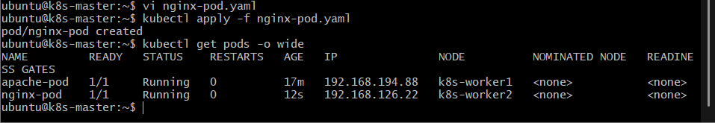
Make sure:
READY = 1/1
STATUS = Running

Step 4 — Create the NodePort Service
Create:
nano nginx-service.yaml
Add:
apiVersion: v1
kind: Service
metadata:
name: nginx-service
spec:
type: NodePort
selector:
app: nginx
ports:
- port: 80
targetPort: 80
nodePort: 30080
Save and exit.
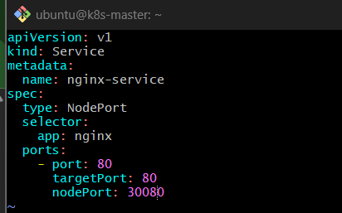

Step 5 — Understand the Service Ports
We have three important values:
port: 80
targetPort: 80
nodePort: 30080
Think of the flow as:
Client
|
| NodeIP:30080
↓
NodePort: 30080
|
| Service port 80
↓
Nginx Pod port 80

nodePort
nodePort: 30080
This is the port exposed on the Kubernetes node.
So the external request looks like:
http://<Node-IP>:30080

port
port: 80
This is the port exposed by the Kubernetes Service.

targetPort
targetPort: 80
This is the port where the Nginx container is listening.

Step 6 — Create the Service
Run:
kubectl apply -f nginx-service.yaml
Expected:
service/nginx-service created

Step 7 — Verify the Service
Run:
kubectl get svc
You should see something similar to:
NAME TYPE CLUSTER-IP EXTERNAL-IP PORT(S)
nginx-service NodePort 10.x.x.x <none> 80:30080/TCP
The important part is:
80:30080/TCP
This means:
Service Port = 80
NodePort = 30080
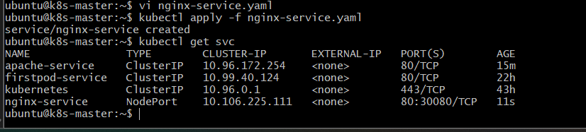

Step 8 — Verify the Endpoint
Run:
kubectl get endpoints nginx-service
You should see something similar to:
NAME ENDPOINTS
nginx-service 192.168.x.x:80
This confirms that the Service has found the Nginx Pod.
The connection is:
nginx-service
|
| selector: app=nginx
↓
nginx-pod
|
↓
port 80

Step 9 — Find the Node IP
Run:
kubectl get nodes -o wide
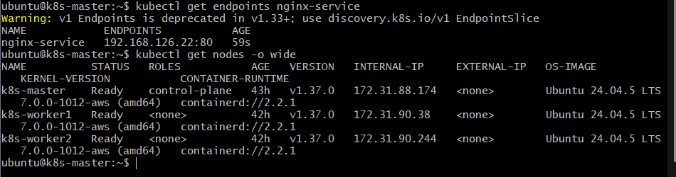
Example:
NAME STATUS ROLES INTERNAL-IP
k8s-master Ready control-plane 172.31.x.x
k8s-worker1 Ready <none> 172.31.x.x
k8s-worker2 Ready <none> 172.31.x.x
For example, if your node IP is:
172.31.90.38
you would access:
http://172.31.90.38:30080

Step 10 — Test from the Kubernetes Node
From a machine that can reach the node, test:
curl http://<NODE-IP>:30080
For example:
curl http://172.31.90.38:30080
You should receive Nginx's HTML response:
<!DOCTYPE html>
<html>
<head>
<title>Welcome to nginx!</title>
...
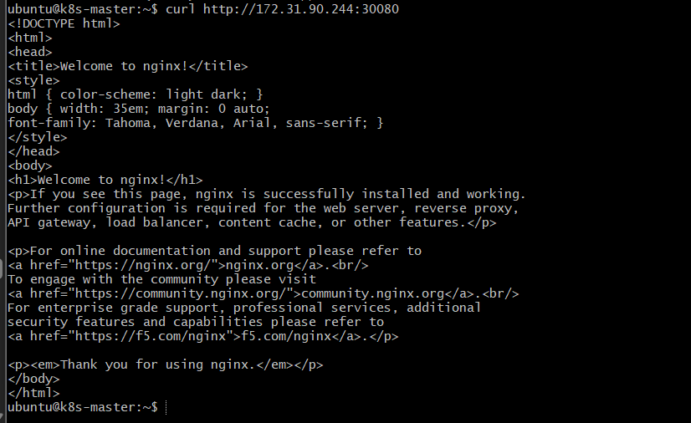
That confirms:
External request
↓
Node IP
↓
NodePort 30080
↓
nginx-service
↓
nginx-pod:80
↓
Nginx

Step 11 — Test from Your Windows Machine

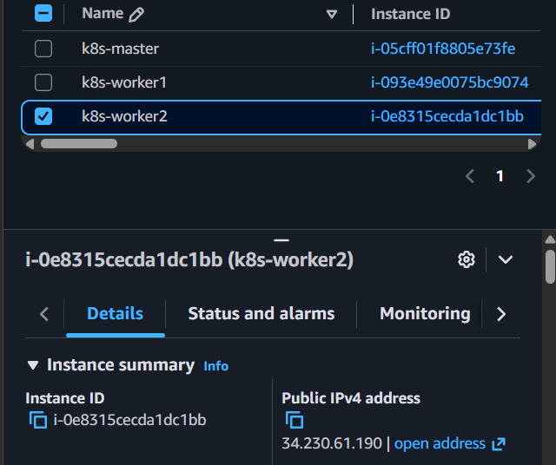
Since your Kubernetes lab uses Ubuntu nodes, if those nodes are reachable from your Windows machine, you can open:
http://<NODE-IP>:30080
in your browser.
You should see:
Welcome to nginx!
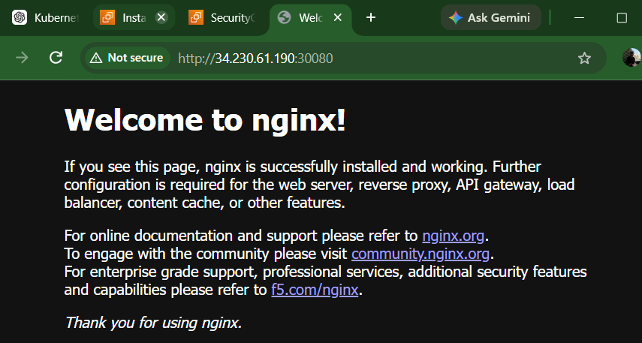

Important for your AWS-based cluster
If your Kubernetes nodes are EC2 instances and you're trying to access NodePort from your local Windows machine, the EC2 Security Group must allow TCP 30080 from your source IP/network.
For example:
Internet
|
| TCP 30080
↓
EC2 Security Group
|
↓
Kubernetes Node
|
↓
NodePort 30080
|
↓
Nginx Pod

Step 12 — Inspect the Service
Run:
kubectl describe svc nginx-service
Look for:
Type: NodePort
Port: 80/TCP
TargetPort: 80/TCP
NodePort: 30080/TCP
Endpoints: <pod-ip>:80
Selector: app=nginx
This gives you the complete Service configuration.
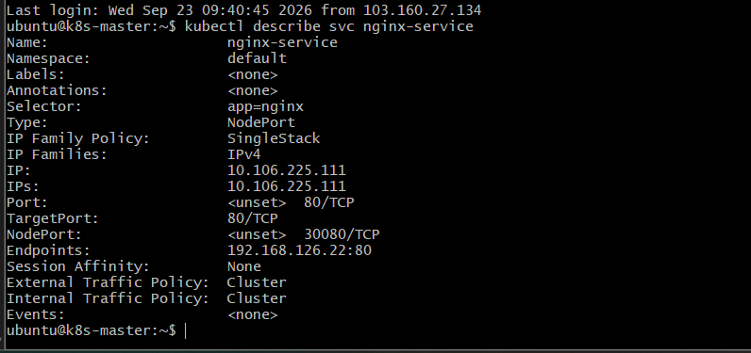

4. Validation Checklist
Run these commands:

Check Pod
kubectl get pod nginx-pod -o wide
Expected:
1/1 Running

Check Service
kubectl get svc nginx-service
Expected:
NodePort
and:
80:30080/TCP

Check endpoint
kubectl get endpoints nginx-service
Expected:
<POD-IP>:80

Check nodes
kubectl get nodes -o wide

Test
curl http://<NODE-IP>:30080
Expected:
Welcome to nginx!

5. ClusterIP vs NodePort
You have now worked with both.
Feature | ClusterIP | NodePort
Default Service type | Yes | No
Internal access | Yes | Yes
External access | Not directly | Yes
Node port | No | Yes
Example | apache-service | nginx-service
External format | — | NodeIP:30080
The key difference:
ClusterIP

Pod → ClusterIP → Pod
↑
Internal only
Whereas:
NodePort

External Client
↓
NodeIP:30080
↓
NodePort Service
↓
Nginx Pod:80

6. Outcome
After completing Task 2, you will have:
- Created an Nginx Pod.
- Created a NodePort Service.
- Connected the Service to the Nginx Pod using a label selector.
- Exposed Nginx on NodePort 30080.
- Tested Nginx using NodeIP:30080.
- Understood the difference between ClusterIP and NodePort.

Task 3 — Deploy a ReplicationController to Maintain 3 Nginx Replicas

1. Objective
Create a ReplicationController (RC) that ensures 3 Nginx Pods are always running.
If one of the Pods is deleted or fails, the ReplicationController automatically creates a replacement Pod to maintain the desired count of 3.
Note: ReplicationController is an older Kubernetes workload API. In modern Kubernetes, ReplicaSet/Deployment is normally preferred. We are using RC here because it is specifically part of your lab.

2. Architecture
ReplicationController
nginx-rc
|
replicas = 3
|
---------------+---------------
| | |
↓ ↓ ↓
Nginx Pod Nginx Pod Nginx Pod
nginx-1 nginx-2 nginx-3

Flow
- We create a ReplicationController named nginx-rc.
- The RC specifies that 3 Pods should exist.
- It uses a selector such as app=nginx-rc.
- The RC creates three Nginx Pods with that label.
- Kubernetes continuously monitors the Pods.
- If one Pod disappears, the RC creates another Pod.
- The desired state remains 3 replicas.

3. Implementation

Step 1 — Check the Existing Pods
Before creating the RC, run:
kubectl get pods
You should still have the resources from Tasks 1 and 2, such as:
apache-pod
nginx-pod
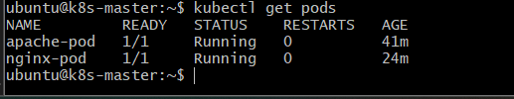
These are not managed by our new ReplicationController because they have different labels.
Our RC will use:
app=nginx-rc

Step 2 — Create the ReplicationController YAML
Create:
nano nginx-rc.yaml
Add:
apiVersion: v1
kind: ReplicationController
metadata:
name: nginx-rc
spec:
replicas: 3

selector:
app: nginx-rc

template:
metadata:
labels:
app: nginx-rc
spec:
containers:
- name: nginx
image: nginx
ports:
- containerPort: 80
Save and exit.
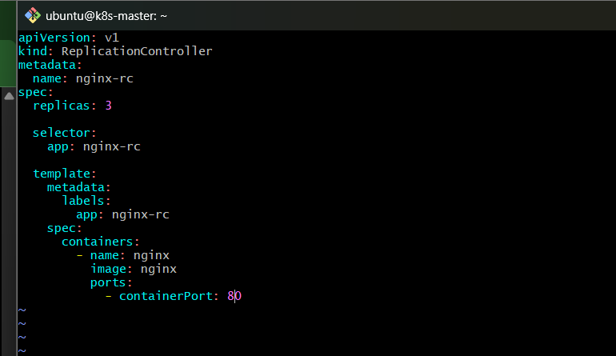

4. Understand the YAML
There are four important sections.

kind
kind: ReplicationController
This tells Kubernetes:
Create a ReplicationController.

replicas
replicas: 3
This is the desired number of Pods.
Desired Pods = 3

selector
selector:
app: nginx-rc
The ReplicationController looks for Pods having:
app=nginx-rc

Pod template
template:
metadata:
labels:
app: nginx-rc
Every Pod created by this RC gets:
app=nginx-rc
Therefore:
ReplicationController
|
| selector: app=nginx-rc
|
+-------- Pod 1
|
+-------- Pod 2
|
+-------- Pod 3

5. Create the ReplicationController
Run:
kubectl apply -f nginx-rc.yaml
Expected:
replicationcontroller/nginx-rc created
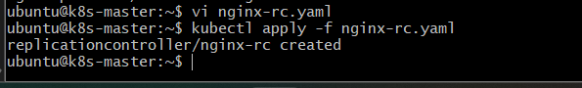

6. Verify the ReplicationController
Run:
kubectl get rc
Expected:
NAME DESIRED CURRENT READY AGE
nginx-rc 3 3 3 ...
The important values are:
DESIRED = 3
CURRENT = 3
READY = 3
This means the ReplicationController successfully created three Pods.
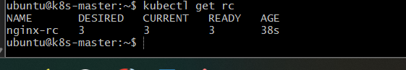

7. Check the Pods
Run:
kubectl get pods
You should see the three new Pods in addition to your existing Pods.
For example:
NAME READY STATUS RESTARTS AGE
apache-pod 1/1 Running 0 ...
nginx-pod 1/1 Running 0 ...
nginx-rc-xxxxx 1/1 Running 0 ...
nginx-rc-yyyyy 1/1 Running 0 ...
nginx-rc-zzzzz 1/1 Running 0 ...
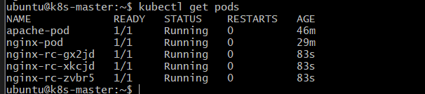

8. Identify Which Pods Belong to the RC
Run:
kubectl get pods --show-labels
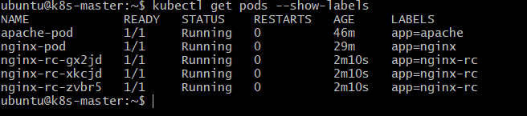
You should see:
nginx-rc-xxxxx ... app=nginx-rc
nginx-rc-yyyyy ... app=nginx-rc
nginx-rc-zzzzz ... app=nginx-rc
The three Pods managed by the RC have:
app=nginx-rc
Your previous Nginx Pod has:
app=nginx
Therefore, the RC doesn't manage it.

9. Verify Using the RC Selector
Run:
kubectl get pods -l app=nginx-rc
Expected:
NAME READY STATUS RESTARTS AGE
nginx-rc-xxxxx 1/1 Running 0 ...
nginx-rc-yyyyy 1/1 Running 0 ...
nginx-rc-zzzzz 1/1 Running 0 ...
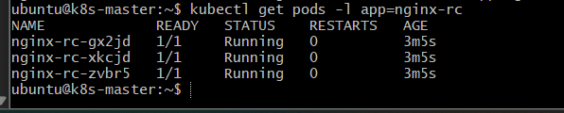
This is a useful command because it shows only the Pods matching the RC's selector.

10. Test Self-Healing
This is the most important part of the task.
First check:
kubectl get pods -l app=nginx-rc
You should have:
3 Pods
Now choose one of those Pods.
For example:
kubectl delete pod nginx-rc-xxxxx
Use your actual Pod name.
You should see:
pod "nginx-rc-xxxxx" deleted
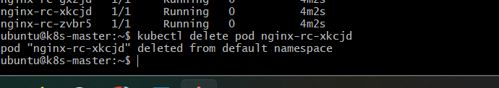

11. Immediately Check the Pods
Run:
kubectl get pods -l app=nginx-rc
You may briefly see something like:
nginx-rc-yyyyy 1/1 Running
nginx-rc-zzzzz 1/1 Running
nginx-rc-aaaaa 0/1 ContainerCreating
The ReplicationController noticed:
Desired = 3
Current = 2
So it creates a replacement.
After a few seconds:
kubectl get pods -l app=nginx-rc
You should again see:
3 Pods
all running.
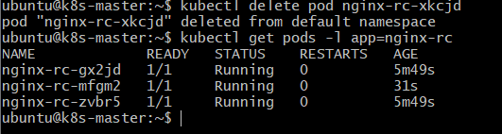

12. Understand the Self-Healing Flow
ReplicationController
|
Desired = 3
|
---------------------
| | |
Pod-1 Pod-2 Pod-3
| | |
Running Running Running
Now Pod-2 is deleted:
ReplicationController
|
Desired = 3
|
---------------------
| |
Pod-1 Pod-3
Running Running

Pod-2
Deleted
The RC detects:
Desired = 3
Current = 2
Therefore:
ReplicationController
|
Desired = 3
|
---------------------
| | |
Pod-1 Pod-3 Pod-4
Running Running Creating
Eventually:
Pod-1 Running
Pod-3 Running
Pod-4 Running
Back to:
3 replicas

In simple words
The ReplicationController's job is not simply to create three Pods once.
Its job is to continuously maintain:
Actual state = Desired state = 3

13. Inspect the ReplicationController
Run:
kubectl describe rc nginx-rc
Look for:
Replicas: 3 current / 3 desired
Pods Status: 3 Running / 0 Waiting / 0 Succeeded / 0 Failed
Selector: app=nginx-rc
This gives you detailed information about the RC.
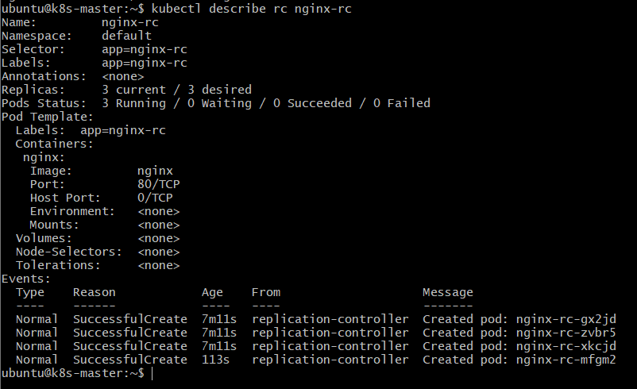

14. Validation Checklist
Run these commands.

Check RC
kubectl get rc
Expected:
nginx-rc 3 3 3

Check managed Pods
kubectl get pods -l app=nginx-rc
Expected:
3 Pods

Check labels
kubectl get pods --show-labels
Confirm the three RC Pods have:
app=nginx-rc

Test self-healing
Delete one managed Pod:
kubectl delete pod <one-nginx-rc-pod>
Then:
kubectl get pods -l app=nginx-rc
After a few seconds:
3 Running Pods

15. Expected Final Architecture
Kubernetes Cluster
|
|
┌──────────────────────┐
│ ReplicationController│
│ nginx-rc │
│ replicas: 3 │
└──────────┬───────────┘
|
selector: app=nginx-rc
|
┌────────────────┼────────────────┐
↓ ↓ ↓
┌──────────┐ ┌──────────┐ ┌──────────┐
│ Nginx │ │ Nginx │ │ Nginx │
│ Pod 1 │ │ Pod 2 │ │ Pod 3 │
└──────────┘ └──────────┘ └──────────┘

16. Outcome
After completing Task 3, you will have:
- Created a ReplicationController named nginx-rc.
- Configured it for 3 replicas.
- Created three Nginx Pods automatically.
- Used labels and selectors to identify managed Pods.
- Tested self-healing by deleting a Pod.
- Verified that the RC automatically created a replacement Pod.

Task 4 — Scale the ReplicationController from 3 to 5 Replicas

1. Objective
Scale the existing nginx-rc ReplicationController from 3 Nginx Pods to 5 Nginx Pods.
We will use the existing ReplicationController from Task 3 rather than creating a new one.

What we will learn
- Scaling a ReplicationController
- Changing desired replica count
- Observing Kubernetes create additional Pods
- Verifying the new desired/current/ready state

2. Architecture

Before scaling
ReplicationController
nginx-rc
replicas = 3
|
-------------+-------------
| | |
Pod-1 Pod-2 Pod-3
Nginx Nginx Nginx

After scaling
ReplicationController
nginx-rc
replicas = 5
|
----------------+----------------
| | | | |
Pod-1 Pod-2 Pod-3 Pod-4 Pod-5
Nginx Nginx Nginx Nginx Nginx

Flow
- The existing ReplicationController currently maintains 3 Pods.
- We change the desired replica count from 3 to 5.
- The ReplicationController compares the desired state with the current state.
- It sees that only 3 Pods exist while 5 are required.
- Kubernetes creates 2 additional Nginx Pods.
- Once they become ready, the RC reaches:
  - Desired = 5
  - Current = 5
  - Ready = 5

3. Check the Current State
Before scaling, run:
kubectl get rc
You should currently see something similar to:
NAME DESIRED CURRENT READY AGE
nginx-rc 3 3 3 ...
This confirms our starting point.
Now check the Pods:
kubectl get pods -l app=nginx-rc
You should have 3 Pods.
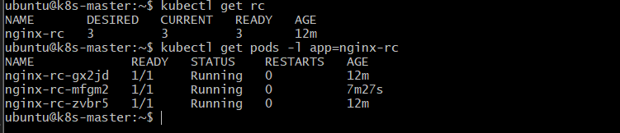

4. Scale the ReplicationController
There are two common ways to scale it.
For this lab, we'll use the kubectl scale command.
Run:
kubectl scale rc nginx-rc --replicas=5
Expected:
replicationcontroller/nginx-rc scaled
This changes:
replicas = 3
to:
replicas = 5

5. Verify the ReplicationController
Run:
kubectl get rc
Expected:
NAME DESIRED CURRENT READY AGE
nginx-rc 5 5 5 ...
The important part is:
DESIRED CURRENT READY
5 5 5
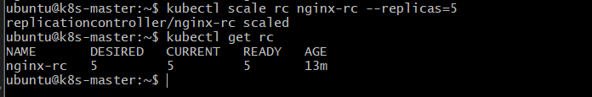

6. Check the Pods
Run:
kubectl get pods -l app=nginx-rc
You should now see 5 Nginx Pods.
For example:
NAME READY STATUS RESTARTS AGE
nginx-rc-abc12 1/1 Running 0 ...
nginx-rc-def34 1/1 Running 0 ...
nginx-rc-ghi56 1/1 Running 0 ...
nginx-rc-jkl78 1/1 Running 0 ...
nginx-rc-mno90 1/1 Running 0 ...
The actual names will be different in your cluster.
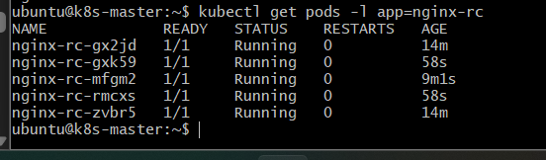

7. Watch Kubernetes Create the New Pods
This is useful for understanding what happens during scaling.
Run:
kubectl get pods -l app=nginx-rc -w
You may initially see the existing 3 Pods and then the two new Pods appear.
For example:
nginx-rc-abc12 1/1 Running
nginx-rc-def34 1/1 Running
nginx-rc-ghi56 1/1 Running
nginx-rc-jkl78 0/1 ContainerCreating
nginx-rc-mno90 0/1 ContainerCreating
Then eventually:
nginx-rc-jkl78 1/1 Running
nginx-rc-mno90 1/1 Running
Press:
Ctrl + C
to stop watching.
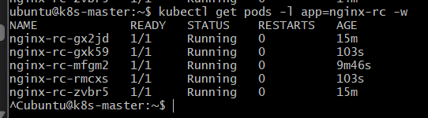

8. Verify Using the Selector
Run:
kubectl get pods -l app=nginx-rc --show-labels
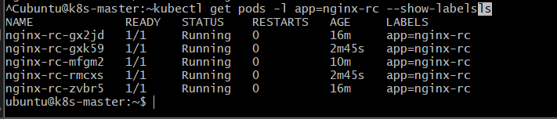
You should have 5 Pods, each with:
app=nginx-rc
Example:
NAME READY STATUS LABELS
nginx-rc-abc12 1/1 Running app=nginx-rc
nginx-rc-def34 1/1 Running app=nginx-rc
nginx-rc-ghi56 1/1 Running app=nginx-rc
nginx-rc-jkl78 1/1 Running app=nginx-rc
nginx-rc-mno90 1/1 Running app=nginx-rc

9. Inspect the ReplicationController
Run:
kubectl describe rc nginx-rc
Look for:
Replicas: 5 current / 5 desired
Pods Status: 5 Running / 0 Waiting / 0 Succeeded / 0 Failed
Selector: app=nginx-rc
This confirms that the RC is maintaining five replicas.
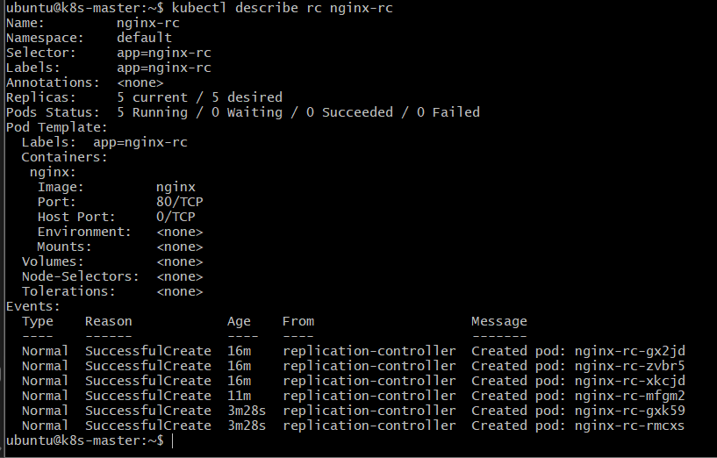

10. Understand What Happened
Before scaling:
Desired = 3
Current = 3
We requested:
Desired = 5
Kubernetes calculated:
5 - 3 = 2
So it created two additional Pods.
Final state:
Desired = 5
Current = 5
Ready = 5

Important concept
Scaling does not mean changing the size of an existing Pod.
Instead:
3 Pods
↓
Scale to 5
↓
5 Pods
Kubernetes creates two new Pods.

11. Architecture After Scaling
nginx-rc
Replicas = 5
|
┌───────────┼───────────┐
| | |
↓ ↓ ↓
Nginx Nginx Nginx
Pod-1 Pod-2 Pod-3

| |
↓ ↓
Nginx Nginx
Pod-4 Pod-5
The ReplicationController continuously ensures:
Actual Pods = 5
If one of these five Pods is deleted:
5 → 4
the RC will create another one:
4 → 5

12. Validation Checklist
Run:

ReplicationController
kubectl get rc nginx-rc
Expected:
DESIRED CURRENT READY
5 5 5

Pods
kubectl get pods -l app=nginx-rc
Expected:
5 Pods

Labels
kubectl get pods -l app=nginx-rc --show-labels
Expected:
app=nginx-rc
for all five Pods.

Detailed verification
kubectl describe rc nginx-rc
Confirm:
5 current / 5 desired

13. Outcome
After completing Task 4, you will have:
- Scaled the existing nginx-rc.
- Increased replicas from 3 → 5.
- Kubernetes automatically created 2 additional Nginx Pods.
- Verified 5 desired, 5 current, 5 ready.
- Confirmed that the ReplicationController continues to maintain the desired number of Pods.

Task 5 — Create a ReplicaSet Using Multiple Labels (prod and test)

1. Objective
Create a ReplicaSet that maintains 3 Nginx Pods and uses multiple label conditions to select the Pods.
For this task, we'll use:
environment=prod
tier=frontend
The ReplicaSet will manage Pods that have both labels.
This is important because ReplicaSets use label selectors to determine which Pods they manage.

2. Architecture
ReplicaSet
nginx-rs
replicas: 3
|
Selector:
environment=prod
AND
tier=frontend
|
--------------+--------------
| | |
↓ ↓ ↓
Pod-1 Pod-2 Pod-3
Nginx Nginx Nginx
prod prod prod
frontend frontend frontend

Flow
- We create a ReplicaSet called nginx-rs.
- The ReplicaSet is configured for 3 replicas.
- Its selector requires:
  - environment=prod
  - tier=frontend
- The Pods created by the ReplicaSet receive both labels.
- The ReplicaSet manages only Pods matching the selector.
- If one matching Pod is deleted, the ReplicaSet creates a replacement.

3. Important Concept — Multiple Labels
A Kubernetes Pod can have many labels.
For example:
labels:
environment: prod
tier: frontend
Think of the Pod as:
Pod
|
+-- environment = prod
|
+-- tier = frontend
Our ReplicaSet will require both:
environment=prod
AND
tier=frontend
This is different from saying:
environment=prod OR tier=frontend
The selector we'll use requires both conditions.

4. Implementation

Step 1 — Create the ReplicaSet YAML
Create:
nano nginx-rs.yaml
Add:
apiVersion: apps/v1
kind: ReplicaSet
metadata:
name: nginx-rs
spec:
replicas: 3

selector:
matchLabels:
environment: prod
tier: frontend

template:
metadata:
labels:
environment: prod
tier: frontend
spec:
containers:
- name: nginx
image: nginx
ports:
- containerPort: 80
Save and exit.
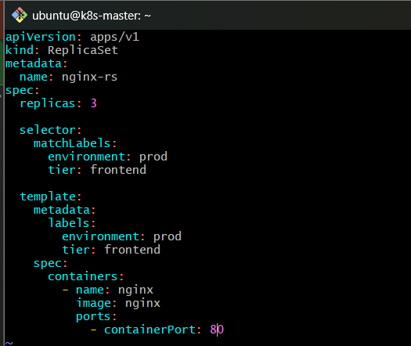

5. Understand the YAML

ReplicaSet
kind: ReplicaSet
We're creating a ReplicaSet.
Unlike the ReplicationController from Tasks 3 and 4, ReplicaSet belongs to the apps/v1 API:
apiVersion: apps/v1

Replicas
replicas: 3
We want:
3 Pods

Selector
This is the most important section:
selector:
matchLabels:
environment: prod
tier: frontend
This means:
Manage Pods having environment=prod AND tier=frontend.

Pod labels
The Pod template contains:
labels:
environment: prod
tier: frontend
So every Pod created by this ReplicaSet has both labels.
The relationship is:
ReplicaSet
|
| matchLabels
|
+-- environment=prod
|
+-- tier=frontend
|
↓
Matching Pods

6. Create the ReplicaSet
Run:
kubectl apply -f nginx-rs.yaml
Expected:
replicaset.apps/nginx-rs created

7. Verify the ReplicaSet
Run:
kubectl get rs
You should see something similar to:
NAME DESIRED CURRENT READY AGE
nginx-rs 3 3 3 ...
The important values are:
DESIRED = 3
CURRENT = 3
READY = 3
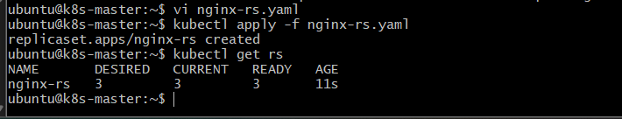

8. Check the Pods
Run:
kubectl get pods
You should see three new Pods with generated names, for example:
nginx-rs-abc12
nginx-rs-def34
nginx-rs-ghi56
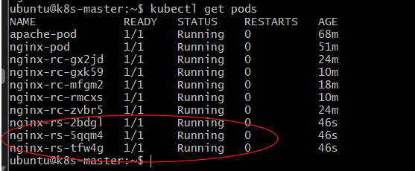

9. Check Only the ReplicaSet Pods
Run:
kubectl get pods -l environment=prod,tier=frontend
You should see:
NAME READY STATUS RESTARTS AGE
nginx-rs-abc12 1/1 Running 0 ...
nginx-rs-def34 1/1 Running 0 ...
nginx-rs-ghi56 1/1 Running 0 ...
This command is using both labels.
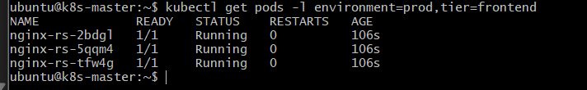

10. Verify the Labels
Run:
kubectl get pods --show-labels
Find the three ReplicaSet Pods.
They should have:
environment=prod,tier=frontend
For example:
NAME READY STATUS LABELS
nginx-rs-abc12 1/1 Running environment=prod,tier=frontend
nginx-rs-def34 1/1 Running environment=prod,tier=frontend
nginx-rs-ghi56 1/1 Running environment=prod,tier=frontend
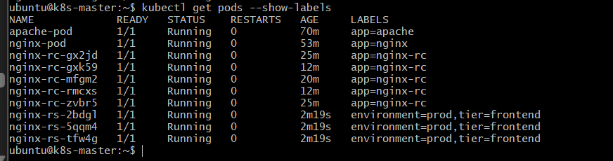

11. Test Each Label Separately
This is a useful way to understand labels.

Find Pods with environment=prod
kubectl get pods -l environment=prod
You should see the three ReplicaSet Pods.

Find Pods with tier=frontend
kubectl get pods -l tier=frontend
You should also see the three ReplicaSet Pods.

Find Pods with both
kubectl get pods -l environment=prod,tier=frontend
Again, you should see the three ReplicaSet Pods.
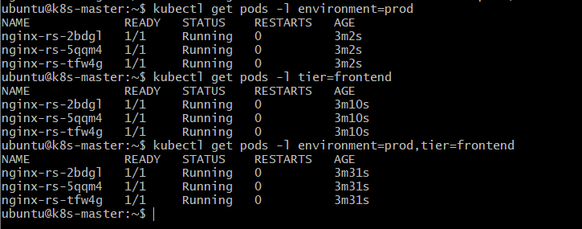

12. Inspect the ReplicaSet
Run:
kubectl describe rs nginx-rs
Look for:
Replicas: 3 current / 3 desired
Pods Status: 3 Running
Selector: environment=prod,tier=frontend
This confirms the ReplicaSet is using both labels.
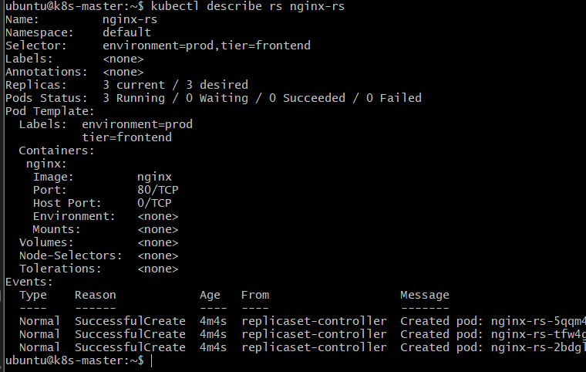

13. Test Self-Healing
Just like the ReplicationController, a ReplicaSet maintains the desired number of Pods.
First:
kubectl get pods -l environment=prod,tier=frontend
You should have 3 Pods.
Choose one and delete it:
kubectl delete pod <nginx-rs-pod-name>
For example:
kubectl delete pod nginx-rs-abc12
Then immediately run:
kubectl get pods -l environment=prod,tier=frontend
You may temporarily see:
2 Running
1 ContainerCreating
After a few seconds:
3 Running
The ReplicaSet automatically created a replacement.
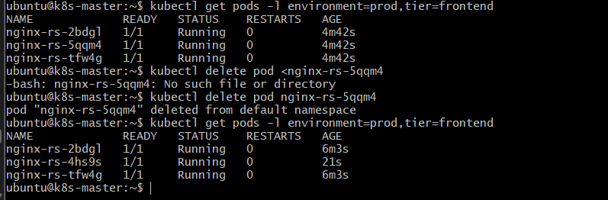

14. Why matchLabels Is Important
We used:
selector:
matchLabels:
environment: prod
tier: frontend
This means:
environment=prod
AND
tier=frontend
For example:
Pod | environment | tier | Managed?
Pod-A | prod | frontend | Yes
Pod-B | prod | backend | No
Pod-C | test | frontend | No
Pod-D | test | backend | No
So the ReplicaSet selects only:
Pod-A

15. Important Difference From Task 3
In Task 3, our ReplicationController used:
selector:
app: nginx-rc
Now the ReplicaSet uses:
selector:
matchLabels:
environment: prod
tier: frontend
So we are learning that a ReplicaSet can select Pods using multiple labels.

16. Validation Checklist
Run:

ReplicaSet
kubectl get rs nginx-rs
Expected:
DESIRED CURRENT READY
3 3 3

Pods matching both labels
kubectl get pods -l environment=prod,tier=frontend
Expected:
3 Pods

Show labels
kubectl get pods --show-labels
Confirm:
environment=prod,tier=frontend

Detailed information
kubectl describe rs nginx-rs
Confirm:
Selector: environment=prod,tier=frontend

Self-healing
Delete one managed Pod:
kubectl delete pod <pod-name>
Then verify:
kubectl get pods -l environment=prod,tier=frontend
The ReplicaSet should return the number to 3.

17. Final Architecture
nginx-rs
ReplicaSet
replicas: 3
|
|
matchLabels:
environment=prod
AND
tier=frontend
|
--------------+--------------
| | |
↓ ↓ ↓
Pod-1 Pod-2 Pod-3
Nginx Nginx Nginx
prod prod prod
frontend frontend frontend

Flow in sentences
The ReplicaSet continuously checks for Pods matching both environment=prod and tier=frontend. It maintains three such Pods. If one is removed, the ReplicaSet creates a replacement with the same labels.

18. Outcome
After completing Task 5, you will have:
- Created a ReplicaSet named nginx-rs.
- Configured it for 3 replicas.
- Used multiple labels.
- Used matchLabels with environment=prod and tier=frontend.
- Verified that only Pods matching both labels are managed.
- Tested ReplicaSet self-healing.

Task 6 — Deploy a ReplicaSet That Excludes Pods With the backend Label

1. Objective
Create a ReplicaSet that maintains 3 Nginx Pods, but selects Pods based on a label condition that excludes Pods having tier=backend.
For this task, we'll use the tier label:
tier=frontend
So:
tier=frontend → managed
tier=backend → excluded
This will help you understand the difference between matchLabels and matchExpressions in ReplicaSets.

2. Architecture

ReplicaSet
nginx-rs-exclude
|
Replica count: 3
|
Selector condition
tier NotIn backend
|
-----------------+-----------------
| | |
↓ ↓ ↓
Pod-1 Pod-2 Pod-3
Nginx Nginx Nginx
tier=frontend tier=frontend tier=frontend
A Pod with:
tier=backend
will not be selected.

Flow
- We create a ReplicaSet with 3 replicas.
- The ReplicaSet uses a matchExpressions selector.
- The selector says tier NotIn backend.
- Therefore, Pods labeled tier=backend don't satisfy the selector.
- The Pods created by our ReplicaSet will use tier=frontend.
- The ReplicaSet maintains 3 matching Pods.

3. Important Concept — matchExpressions
Previously, in Task 5, we used:
matchLabels:
environment: prod
tier: frontend
Now we'll use:
matchExpressions:
- key: tier
operator: NotIn
values:
- backend
This means:
Select Pods whose tier value is not backend.

Common matchExpressions operators
Operator | Meaning
In | Label value must be one of the specified values
NotIn | Label value must not be one of the specified values
Exists | Label key must exist
DoesNotExist | Label key must not exist
For this task:
NotIn backend
is the important one.

4. Implementation

Step 1 — Create the ReplicaSet YAML
Create:
nano nginx-rs-exclude.yaml
Add:
apiVersion: apps/v1
kind: ReplicaSet
metadata:
name: nginx-rs-exclude
spec:
replicas: 3

selector:
matchExpressions:
- key: tier
operator: NotIn
values:
- backend

template:
metadata:
labels:
tier: frontend
spec:
containers:
- name: nginx
image: nginx
ports:
- containerPort: 80
Save and exit.
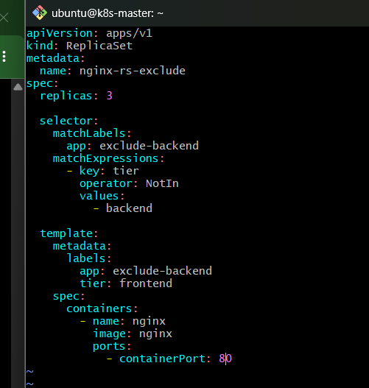

5. Understand the Selector
The important section is:
selector:
matchExpressions:
- key: tier
operator: NotIn
values:
- backend
It means:
Does Pod have tier=backend?
|
YES → Exclude
|
NO
↓
Select Pod
For example:
Pod | Label | Selected?
Pod-A | tier=frontend | Yes
Pod-B | tier=backend | No
Pod-C | tier=database | Yes
Pod-D | tier=test | Yes
The selector specifically excludes the value backend.

6. Create the ReplicaSet
Run:
kubectl apply -f nginx-rs-exclude.yaml
Expected:
replicaset.apps/nginx-rs-exclude created

7. Verify the ReplicaSet
Run:
kubectl get rs
You should see both ReplicaSets from Tasks 5 and 6.
For example:
NAME DESIRED CURRENT READY
nginx-rs 3 3 3
nginx-rs-exclude 3 3 3
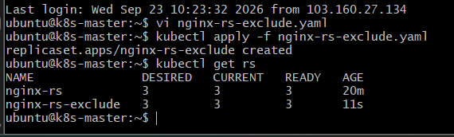
For our new ReplicaSet:
nginx-rs-exclude
we want:
DESIRED = 3
CURRENT = 3
READY = 3

8. Find the New ReplicaSet Pods
Run:
kubectl get pods --show-labels
You should find three new Pods with:
tier=frontend
For example:
NAME READY STATUS LABELS
nginx-rs-exclude-abc12 1/1 Running tier=frontend
nginx-rs-exclude-def34 1/1 Running tier=frontend
nginx-rs-exclude-ghi56 1/1 Running tier=frontend
The actual names will be different.
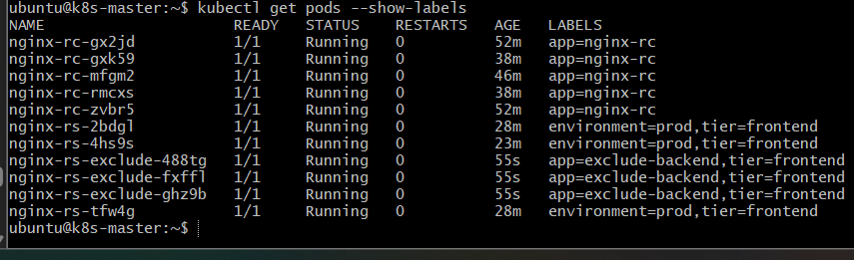

9. Verify Using the Label Selector
Run:
kubectl get pods -l tier=frontend
You may see Pods from Task 5 as well, because those Pods also have:
tier=frontend
That's expected.
To identify only the Pods created by this ReplicaSet, use:
kubectl get pods --show-labels
and look for names beginning with:
nginx-rs-exclude-
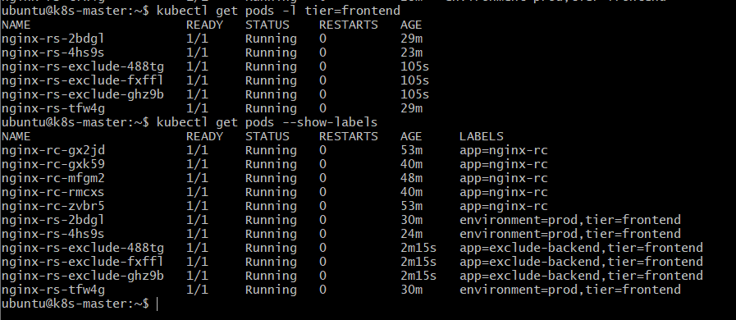

10. Create a Backend Pod for Testing
Now we need to prove that the ReplicaSet excludes a Pod with:
tier=backend
Create a simple test Pod:
kubectl run backend-test --image=nginx --labels=tier=backend
Expected:
pod/backend-test created

11. Verify the Backend Pod
Run:
kubectl get pod backend-test --show-labels
Expected:
NAME READY STATUS LABELS
backend-test 1/1 Running tier=backend
This Pod has:
tier=backend
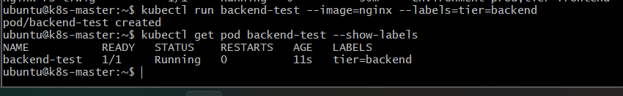

12. Check Whether the ReplicaSet Adopted the Backend Pod
Run:
kubectl describe rs nginx-rs-exclude
Look at:
Selector:
You should see something similar to:
Selector: tier notin (backend)
The ReplicaSet should still have:
Replicas: 3 current / 3 desired
The backend-test Pod should not become one of its managed Pods.
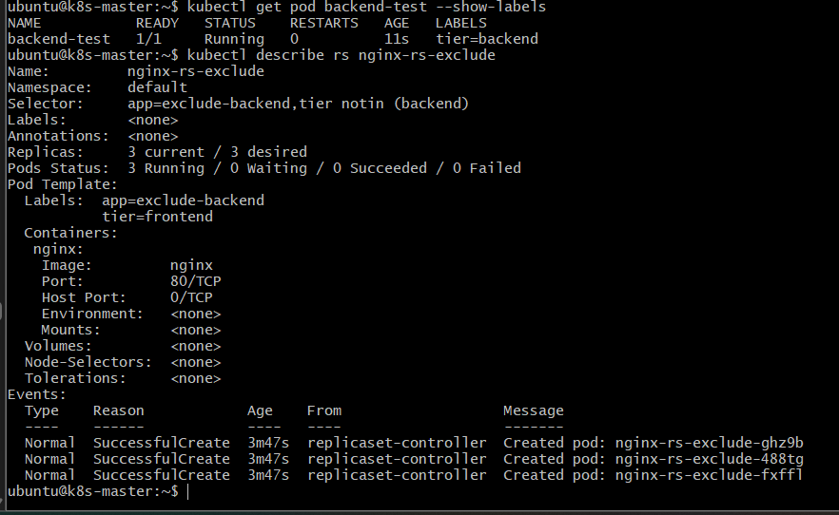

13. Prove the Exclusion
We now have:
ReplicaSet selector:

tier NotIn backend
And:
backend-test
tier=backend
Therefore:
backend-test
|
| tier=backend
↓
Not selected by nginx-rs-exclude
The three ReplicaSet Pods remain:
nginx-rs-exclude-xxxxx tier=frontend
nginx-rs-exclude-yyyyy tier=frontend
nginx-rs-exclude-zzzzz tier=frontend

14. Test Self-Healing
Delete one of the Pods created by the ReplicaSet.
First find them:
kubectl get pods --show-labels
Choose one beginning with:
nginx-rs-exclude-
Then:
kubectl delete pod <pod-name>
For example:
kubectl delete pod nginx-rs-exclude-abc12
Now run:
kubectl get pods
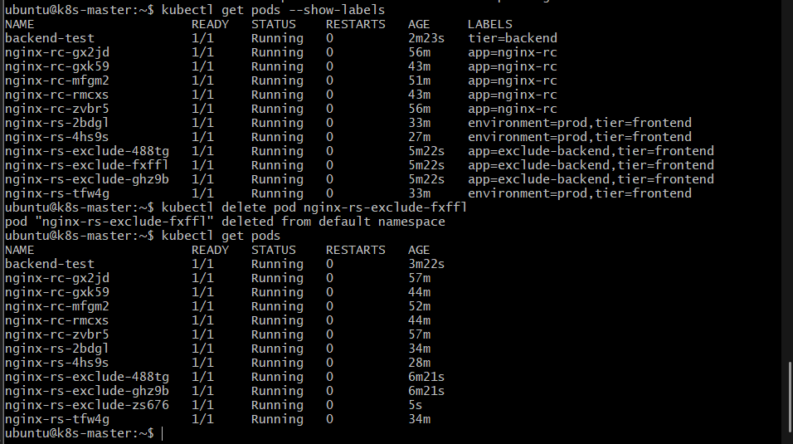
You should temporarily see the replacement being created.
After a few seconds:
kubectl get rs nginx-rs-exclude
Expected:
NAME DESIRED CURRENT READY
nginx-rs-exclude 3 3 3

15. Final Architecture
Kubernetes Cluster
│
┌─────────────┴─────────────┐
│ │
Task 5 ReplicaSet Task 6 ReplicaSet
nginx-rs nginx-rs-exclude
│ │
3 Pods 3 Pods
│ │
┌─────────┼─────────┐ ┌─────────┼─────────┐
│ │ │ │ │ │
Pod Pod Pod Pod Pod Pod
│ │ │ │ │ │
env=prod env=prod env=prod app= app= app=
tier= tier= tier= exclude- exclude- exclude-
frontend frontend frontend backend backend backend
tier= tier= tier=
frontend frontend frontend

Flow
• nginx-rs-exclude is responsible for maintaining 3 Nginx Pods.
• It looks for Pods having app=exclude-backend.
• It additionally checks that tier is not backend.
• Therefore, Pods with app=exclude-backend,tier=frontend are managed by this ReplicaSet.
• Pods with app=exclude-backend,tier=backend are excluded.

• The unique app=exclude-backend label prevents this ReplicaSet from conflicting with the Task 5 nginx-rs.

16. Cleanup of the Test Pod
The backend-test Pod was created only for validation.
Remove it with:
kubectl delete pod backend-test
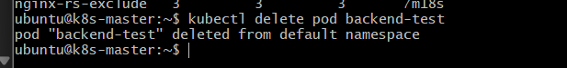

17. Outcome
After completing Task 6, you will have:
- Created a ReplicaSet using matchExpressions.
- Configured tier NotIn backend.
- Created 3 Nginx Pods with tier=frontend.
- Created a tier=backend test Pod.
- Verified that the backend Pod is excluded from the ReplicaSet.
- Tested ReplicaSet self-healing.
- Learned the difference between matchLabels and matchExpressions.

Task 7 — Test Load Balancing Across Multiple Pods Using a NodePort Service

1. Objective
In this task, we will create a NodePort Service that routes traffic to multiple Nginx Pods and verify that the Service can distribute requests across those Pods.
We already have multiple Nginx Pods from previous tasks, but for a clean load-balancing demonstration, we'll create a dedicated set of 3 Nginx Pods using a ReplicaSet.
We'll then expose them through a NodePort Service.

What we will learn
- Service selectors
- Multiple Pod endpoints
- NodePort
- Kubernetes Service load balancing
- How a Service distributes traffic among multiple Pods
- How to identify which Pod handled a request

2. Architecture
External Client
|
|
NodeIP:30081
|
↓
┌──────────────────┐
│ NodePort Service│
│ nginx-lb-service │
│ :30081 │
└────────┬─────────┘
|
Service Selector
app=nginx-lb
|
--------------+--------------
| | |
↓ ↓ ↓
Pod-1 Pod-2 Pod-3
Nginx Nginx Nginx

Flow
- We create three Nginx Pods.
- All three Pods receive the same label: app=nginx-lb.
- We create a NodePort Service.
- The Service selects all three Pods using app=nginx-lb.
- The Service gets three endpoints.
- An external request reaches NodeIP:30081.
- Kubernetes forwards the request to one of the available Nginx Pods.
- Repeated requests can be distributed across the available backend Pods.

3. Step 1 — Create a ReplicaSet With 3 Nginx Pods
Create:
vi nginx-lb-rs.yaml
Add:
apiVersion: apps/v1
kind: ReplicaSet
metadata:
name: nginx-lb-rs
spec:
replicas: 3
selector:
matchLabels:
app: nginx-lb
template:
metadata:
labels:
app: nginx-lb
spec:
containers:
- name: nginx
image: nginx
ports:
- containerPort: 80
Save and exit.
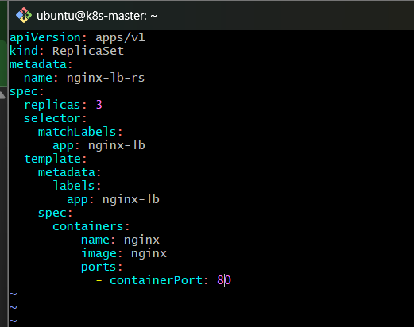

4. Step 2 — Create the ReplicaSet
Run:
kubectl apply -f nginx-lb-rs.yaml
Expected:
replicaset.apps/nginx-lb-rs created

5. Step 3 — Verify the ReplicaSet
Run:
kubectl get rs nginx-lb-rs
Expected:
NAME DESIRED CURRENT READY
nginx-lb-rs 3 3 3

6. Step 4 — Verify the Three Pods
Run:
kubectl get pods -l app=nginx-lb -o wide
Expected:
NAME READY STATUS IP
nginx-lb-rs-xxxxx 1/1 Running 192.168.x.x
nginx-lb-rs-yyyyy 1/1 Running 192.168.x.x
nginx-lb-rs-zzzzz 1/1 Running 192.168.x.x
You should have exactly 3 Pods.
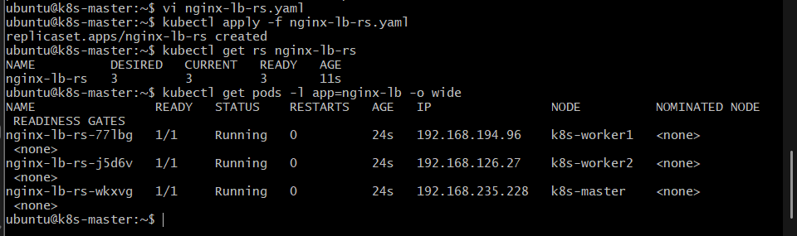

7. Step 5 — Create the NodePort Service
Create:
vi nginx-lb-service.yaml
Add:
apiVersion: v1
kind: Service
metadata:
name: nginx-lb-service
spec:
type: NodePort
selector:
app: nginx-lb
ports:
- port: 80
targetPort: 80
nodePort: 30081
Save and exit.
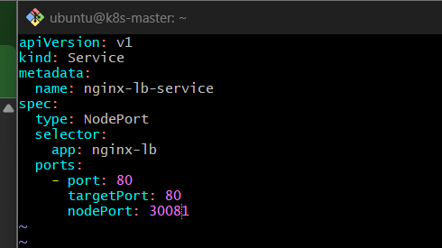

8. Step 6 — Create the Service
Run:
kubectl apply -f nginx-lb-service.yaml
Expected:
service/nginx-lb-service created

9. Step 7 — Verify the Service
Run:
kubectl get svc nginx-lb-service
Expected:
NAME TYPE CLUSTER-IP EXTERNAL-IP PORT(S)
nginx-lb-service NodePort 10.x.x.x <none> 80:30081/TCP
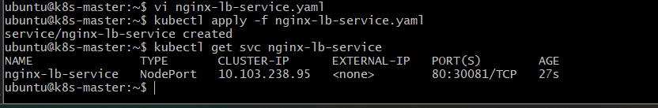
The important part is:
80:30081/TCP
Meaning:
NodePort = 30081
Service = 80
Pod = 80

10. Step 8 — Verify the Service Endpoints
This is an important step.
Run:
kubectl get endpoints nginx-lb-service
You should see three Pod IPs:
NAME ENDPOINTS
nginx-lb-service 192.168.x.x:80,192.168.x.x:80,192.168.x.x:80
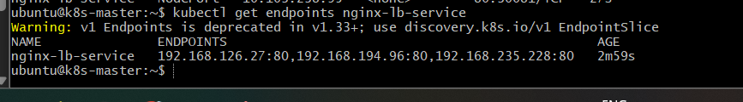
This proves the Service has discovered all three Pods.
Architecture:
nginx-lb-service
|
| selector: app=nginx-lb
|
+------ Pod-1 :80
|
+------ Pod-2 :80
|
+------ Pod-3 :80

11. Step 9 — Find the Node IP
Run:
kubectl get nodes -o wide
For example:
NAME STATUS INTERNAL-IP
k8s-master Ready 172.31.x.x
k8s-worker1 Ready 172.31.x.x
k8s-worker2 Ready 172.31.x.x
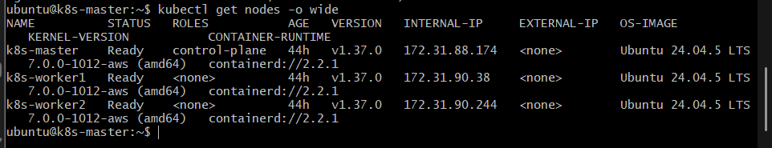
Use a reachable node IP.
Then the NodePort URL is:
http://<NODE-IP>:30081

12. Step 10 — Test the Service
Run:
curl http://<NODE-IP>:30081
You should get the Nginx response:
<!DOCTYPE html>
<html>
<head>
<title>Welcome to nginx!</title>
...
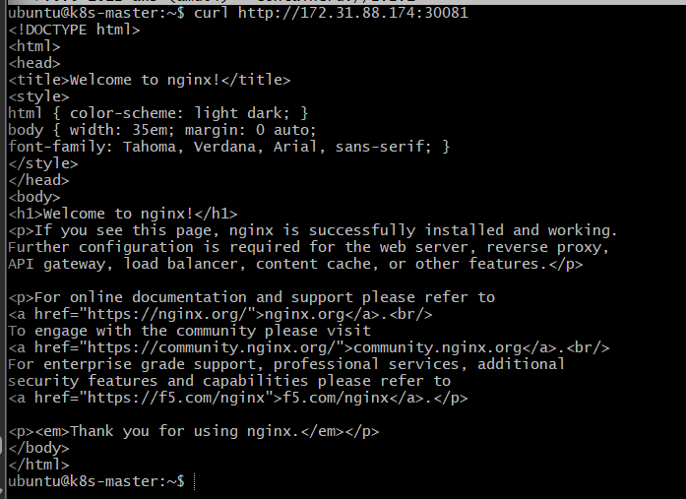
At this point, we know the NodePort Service is working.
But we also want to demonstrate that multiple Pods are behind the Service.

13. Step 11 — See Which Pods Are Behind the Service
Run:
kubectl get pods -l app=nginx-lb -o wide
Then:
kubectl get endpoints nginx-lb-service
Compare the Pod IPs.
For example:
Pod-1 → 192.168.194.81
Pod-2 → 192.168.194.82
Pod-3 → 192.168.194.83
and:
Service endpoints:
192.168.194.81:80
192.168.194.82:80
192.168.194.83:80
This means the Service has three possible backend destinations.
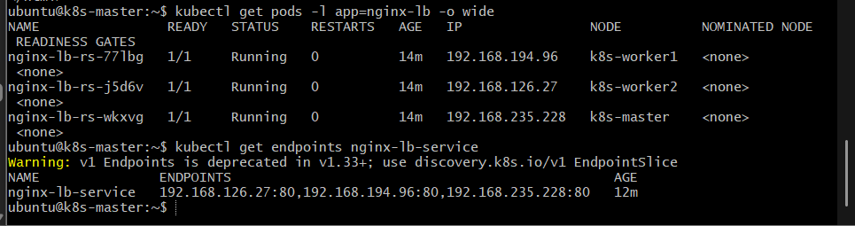

14. Step 12 — Understand the Load Balancing
The request flow is:
Client
|
| http://NodeIP:30081
↓
NodePort
|
↓
nginx-lb-service
|
+-------- Pod-1
|
+-------- Pod-2
|
+-------- Pod-3
The Service provides a single access point while the Pods provide multiple backend instances.
So the client doesn't need to know:
Pod-1 IP
Pod-2 IP
Pod-3 IP
The client only needs:
NodeIP:30081

15. Step 13 — Test Multiple Requests
Run:
for i in {1..20}; do curl -s http://<NODE-IP>:30081 | grep -o "<title>[^<]*</title>"; done
You should receive repeated Nginx responses.
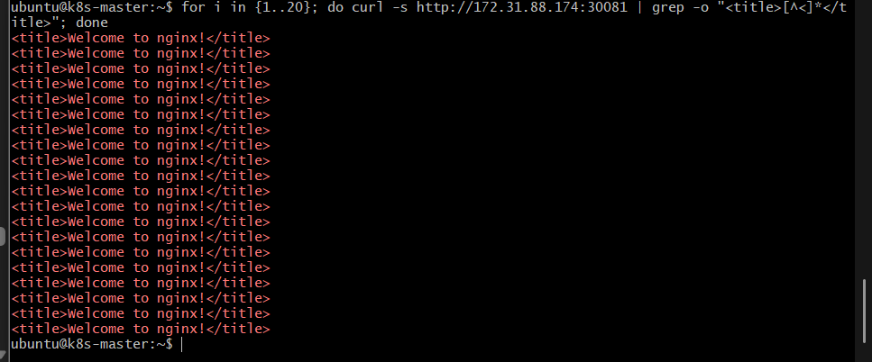
However, there's an important point:

The default Nginx page is identical on all Pods.
Therefore, even if traffic is being distributed between Pods, the output will look the same:
<title>Welcome to nginx!</title>
So the identical response does not prove which Pod handled each request.
For a proper load-balancing demonstration, we should make each Pod return identifiable information.

16. Step 14 — Identify the Pod Handling the Request
We can temporarily modify the Nginx Pods so their responses contain their own Pod hostname.
The Nginx container automatically has its Pod hostname available.
Run:
kubectl exec -it <one-nginx-lb-pod> -- hostname
For example:
nginx-lb-rs-abc12
Do the same for the other Pods:
kubectl get pods -l app=nginx-lb
You'll have something like:
nginx-lb-rs-abc12
nginx-lb-rs-def34
nginx-lb-rs-ghi56

17. Easier Way to Understand the Test
The most important validation for this task is:
kubectl get endpoints nginx-lb-service
You should have:
3 endpoints
That proves the NodePort Service has three backend Pods.
Then:
curl http://<NODE-IP>:30081
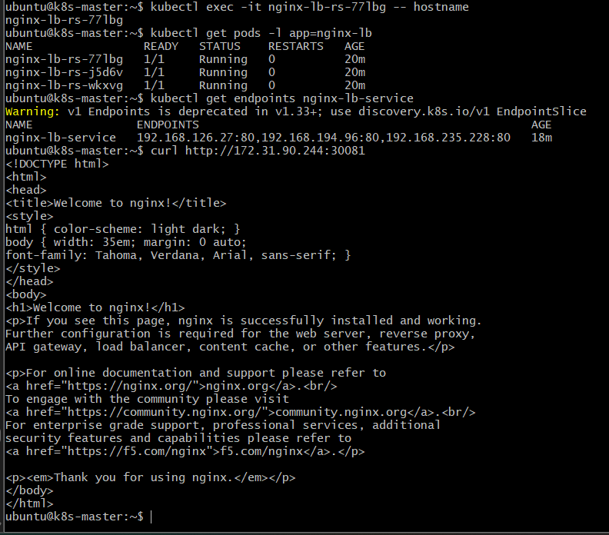
proves that traffic reaches the Service and ultimately an Nginx Pod.
The architecture is:
NodeIP:30081
|
↓
nginx-lb-service
|
┌──────────────┼──────────────┐
↓ ↓ ↓
Pod-1 Pod-2 Pod-3

18. Validation Checklist
Run these commands:

ReplicaSet
kubectl get rs nginx-lb-rs
Expected:
3 3 3

Pods
kubectl get pods -l app=nginx-lb -o wide
Expected:
3 Running Pods

Service
kubectl get svc nginx-lb-service
Expected:
NodePort
80:30081/TCP

Endpoints
kubectl get endpoints nginx-lb-service
Expected:
3 Pod-IP:80 endpoints

External test
curl http://<NODE-IP>:30081
Expected:
Welcome to nginx!

19. Final Architecture
External Client
|
|
NodeIP:30081
|
↓
┌───────────────────┐
│ nginx-lb-service │
│ NodePort │
│ :30081 │
└─────────┬─────────┘
|
selector: app=nginx-lb
|
┌────────────────┼────────────────┐
| | |
↓ ↓ ↓
┌──────────┐ ┌──────────┐ ┌──────────┐
│ Nginx │ │ Nginx │ │ Nginx │
│ Pod-1 │ │ Pod-2 │ │ Pod-3 │
│ :80 │ │ :80 │ │ :80 │
└──────────┘ └──────────┘ └──────────┘

Flow
The external client sends traffic to the NodePort. The NodePort forwards it to nginx-lb-service. The Service uses the app=nginx-lb selector to identify the three Nginx Pods. Kubernetes can then route requests to the available backend Pods, providing Service-level load distribution.

20. Outcome
After Task 7, you will have:
- Created 3 Nginx Pods.
- Created a NodePort Service.
- Connected the Service to all 3 Pods using a label selector.
- Verified that the Service has 3 endpoints.
- Accessed the application externally through the NodePort.
- Understood how Kubernetes Services provide a single endpoint in front of multiple Pods.

Task 8 — Delete a ReplicationController Without Affecting Running Pods

1. Objective
Delete the existing nginx-rc ReplicationController without deleting the Pods it currently manages.
We will use:
--cascade=orphan
This tells Kubernetes:
Delete the ReplicationController, but leave its Pods running.

2. Architecture

Before
ReplicationController
nginx-rc
|
-------------------
| | |
Pod-1 Pod-2 Pod-3
Running Running Running

After
ReplicationController
DELETED
X

-------------------
| | |
Pod-1 Pod-2 Pod-3
Running Running Running
The Pods continue running, but they are no longer managed by the ReplicationController.

3. Required Steps

Step 1 — Verify the RC
Run:
kubectl get rc nginx-rc
You should see:
NAME DESIRED CURRENT READY
nginx-rc 5 5 5
Remember, we scaled this RC to 5 replicas in Task 4.

Step 2 — Verify Its Pods
Run:
kubectl get pods -l app=nginx-rc
You should see 5 Pods.

Step 3 — Delete the RC but Keep the Pods
Run:
kubectl delete rc nginx-rc --cascade=orphan
Expected:
replicationcontroller "nginx-rc" deleted
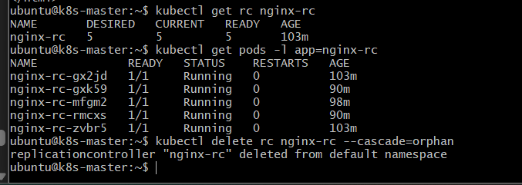

Important
Do not run:
kubectl delete rc nginx-rc
because the default deletion behavior can also delete the Pods managed by the RC.
We specifically need:
--cascade=orphan

Step 4 — Verify the RC Is Deleted
Run:
kubectl get rc
You should not see:
nginx-rc

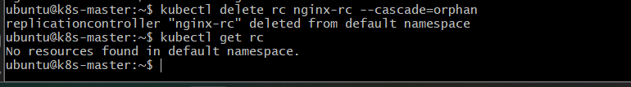

Step 5 — Verify the Pods Are Still Running
Run:
kubectl get pods -l app=nginx-rc
You should still see the 5 Nginx Pods:
NAME READY STATUS
nginx-rc-xxxxx 1/1 Running
nginx-rc-yyyyy 1/1 Running
nginx-rc-zzzzz 1/1 Running
...
This proves the Pods survived the RC deletion.
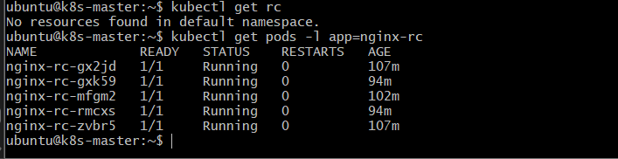

Step 6 — Verify They Are Now Orphaned
Run:
kubectl describe pod <one-nginx-rc-pod>
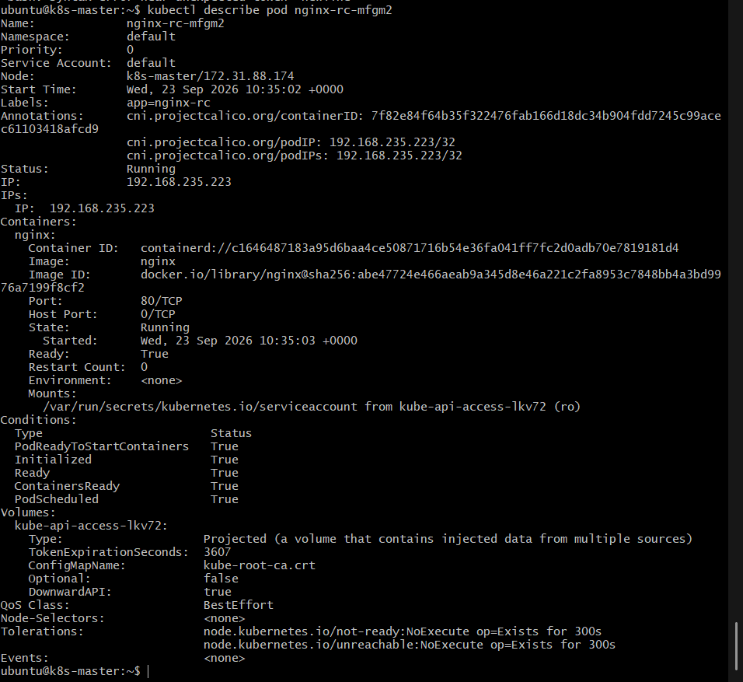
The Pod should no longer be controlled by the deleted ReplicationController.
You can also run:
kubectl get pods -l app=nginx-rc
The Pods will continue running, but there is no ReplicationController maintaining them anymore.
For example, if you manually delete one:
kubectl delete pod <one-nginx-rc-pod>
it will not be recreated, because the RC that previously maintained it has been deleted.

4. Validation
Run:
kubectl get rc
→ nginx-rc should be gone.
Then:
kubectl get pods -l app=nginx-rc
→ The 5 Pods should still be running.
Finally, optionally prove there is no self-healing:
kubectl delete pod <one-nginx-rc-pod>
kubectl get pods -l app=nginx-rc
The number will decrease from 5 to 4 and no replacement will be created.
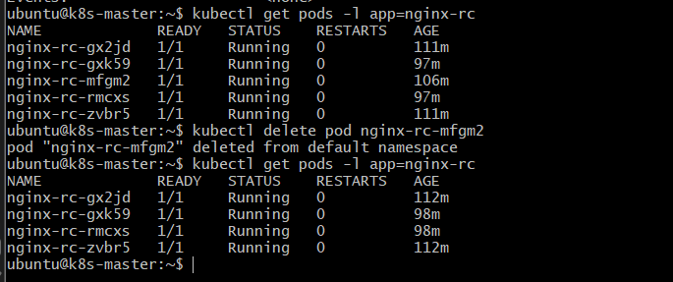

5. Outcome
You have demonstrated:
ReplicationController
|
| --cascade=orphan
↓
DELETED

Pods
↓
CONTINUE RUNNING
Key command:
kubectl delete rc nginx-rc --cascade=orphan

